Lab 8: Summarizing the Data Frame
Week 5 Lab Output Result
Alan B. Palayil
University of the Cumberlands
Course: ITS836 – Big Data Analytics
Instructor: Dr. Charles Edeki
Date: November 22nd, 2025

Step 1 – Loading the Dataset
The dataset Lab 8 – Treatment.xls was successfully loaded (via the CSV version), containing 64 rows and 4 columns. The columns were:
Group, Treatment, Replicate, RelativeFitness.
The first five rows confirmed the dataset structure and data types.
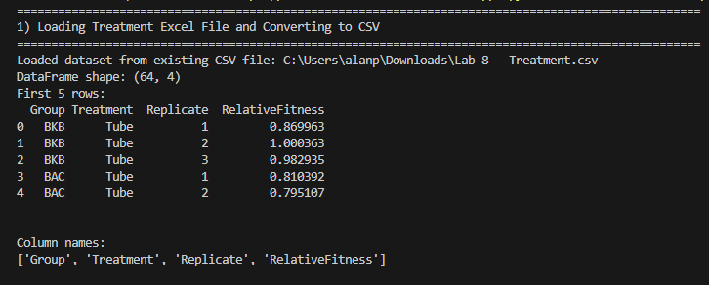

Step 2 – Grouping by Treatment
When grouping by the Treatment column, the dataset showed:
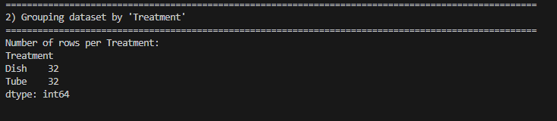
This indicates that the dataset is perfectly balanced, with equal amounts of Dish and Tube treatments.

Step 3 – Distribution of Relative Fitness per Treatment
Using describe(), the following patterns were observed:
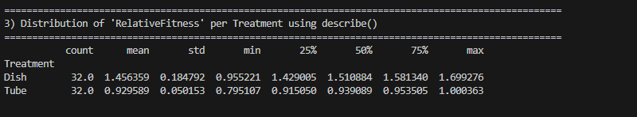
Summary Observation
- Dish treatments show significantly higher Relative Fitness than Tube treatments.
- Dish also shows much more variation, as seen from the larger standard deviation.
- Tube values are lower and more tightly clustered.
This implies that the Dish environment consistently yields higher fitness values.

Step 4 – Grouping by Treatment and Group
The output revealed the mean fitness values for each group under both Dish and Tube:
- For every single group, the Dish fitness values were much higher than the Tube fitness values.
- Variability (std) within groups was generally low, but consistently higher in Dish.
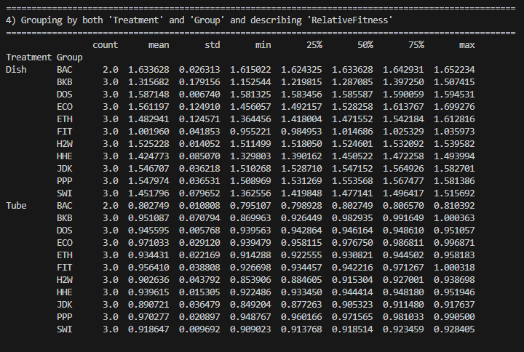
Conclusion
Groups respond consistently:
Dish > Tube across every group, with no exceptions.
This suggests a strong environmental effect rather than group-specific behavior.

Step 5 – Aggregation Functions
Applying mean, median, max, sum, and std:
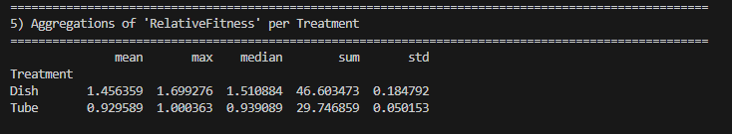
Interpretation
- Dish treatments produce a higher total fitness, higher peak fitness, and larger spread.
- Tube treatments are more consistent but lower performing.

Step 6 – Additional Observations
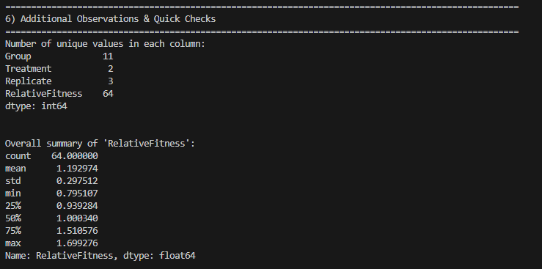
- RelativeFitness had 64 unique values, meaning all measurements were distinct.
- Group had 11 unique categories, indicating diverse sample groups.
- Overall RelativeFitness showed:
  - Mean: 1.19
  - Median: 1.00
  - Std Dev: 0.297
  - Range: 0.795 → 1.699
The dataset appears clean and well-structured.
The clearest pattern is that Dish environments universally produce higher fitness, regardless of group.

